**Project Title - JUGAAD**

**Field of Invention**

This invention relates to Sustainable development. To be more specific, this invention pertains to groove Goal 12 which is to “Ensure sustainable consumption and production patterns”. By preventing, reducing, recycling, and reusing waste, it was stated that waste creation will be significantly reduced by 2030.

**Background**

Jugaad means innovation which is the core of development. Jugaad thinking aids in keeping our attention on the essentials and the true needs, and it frequently results in making the mental transition necessary for a revolutionary new design or product. Jugaad is the core thought process behind REUSE and UPCYCLING of things.

Creating a Jugaad takes a lot of efforts as it requires an innovative and useful approach with several constraints to hinder the outcome. There are several constraints such as time, money, resources, labor, technical knowledge. Most of the greatest and most systematic innovations of the world were once nothing more than a Jugaad. Jugaad is just a solution to adverse circumstances.

We use a lot of jugaad in our daily lives without even realizing. From reusing cooldrink bottles for drinking water to using old clothes as rugs for cleaning. Jugaad can be process- or product-oriented. Process-oriented Jugaad uses a principle or process from one context or product to another, for example, using a motorcycle engine to generate electricity to light homes in remote villages and room heating using a cooking gas cylinder. Product-oriented Jugaad creates innovative products like the Jugaad Vehicle or Mitticool refrigerator.

These innovations can serve a bigger purpose in the world’s technological development if bigger minds are put in focusing on how to evolve and support such inventions to inculcate a culture of innovation among the youth. These innovations may seem petty in front of a well-defined systematic approach, but this also serves a root for greater cause which is advancement in the curative minds which if supported properly could solve many emerging issues.

To bring in light such creative and wonderful attempts and ideas, a book named Jugaad Innovation is written by Navi Radjou, Jaideep Prabhu, Simone Ahuja. This book sheds light on the resourceful and adaptable attitude of thousands of brilliant businesspeople using jugaad to ingeniously handle pressing socioeconomic concerns in their communities.

**Objectives**

We plan to develop a solution to showcase this talent to a more supportive and curious audience using a website known as JUGAAD. Jugaad is a web platform which will provide certain life hacks to the users which will be in the form of blogging Website.

It will be a CRUD website where users can share their daily life examples of how they have used Jugaad. Aside from writing blogs, we'll partner with NGOs and verified investors or offer membership features that will allow them to form communities and work toward a sustainable future. We will be using Machine Learning algorithms for making search processes easier and more effective for the users for searching blogs or any related items.

**Technology Used**

* ReactJS - Frontend
* NodeJS – Backend
* Firebase – Database
* Stripe API – Payment Gateway

**Figures/Models**

Flow Chart

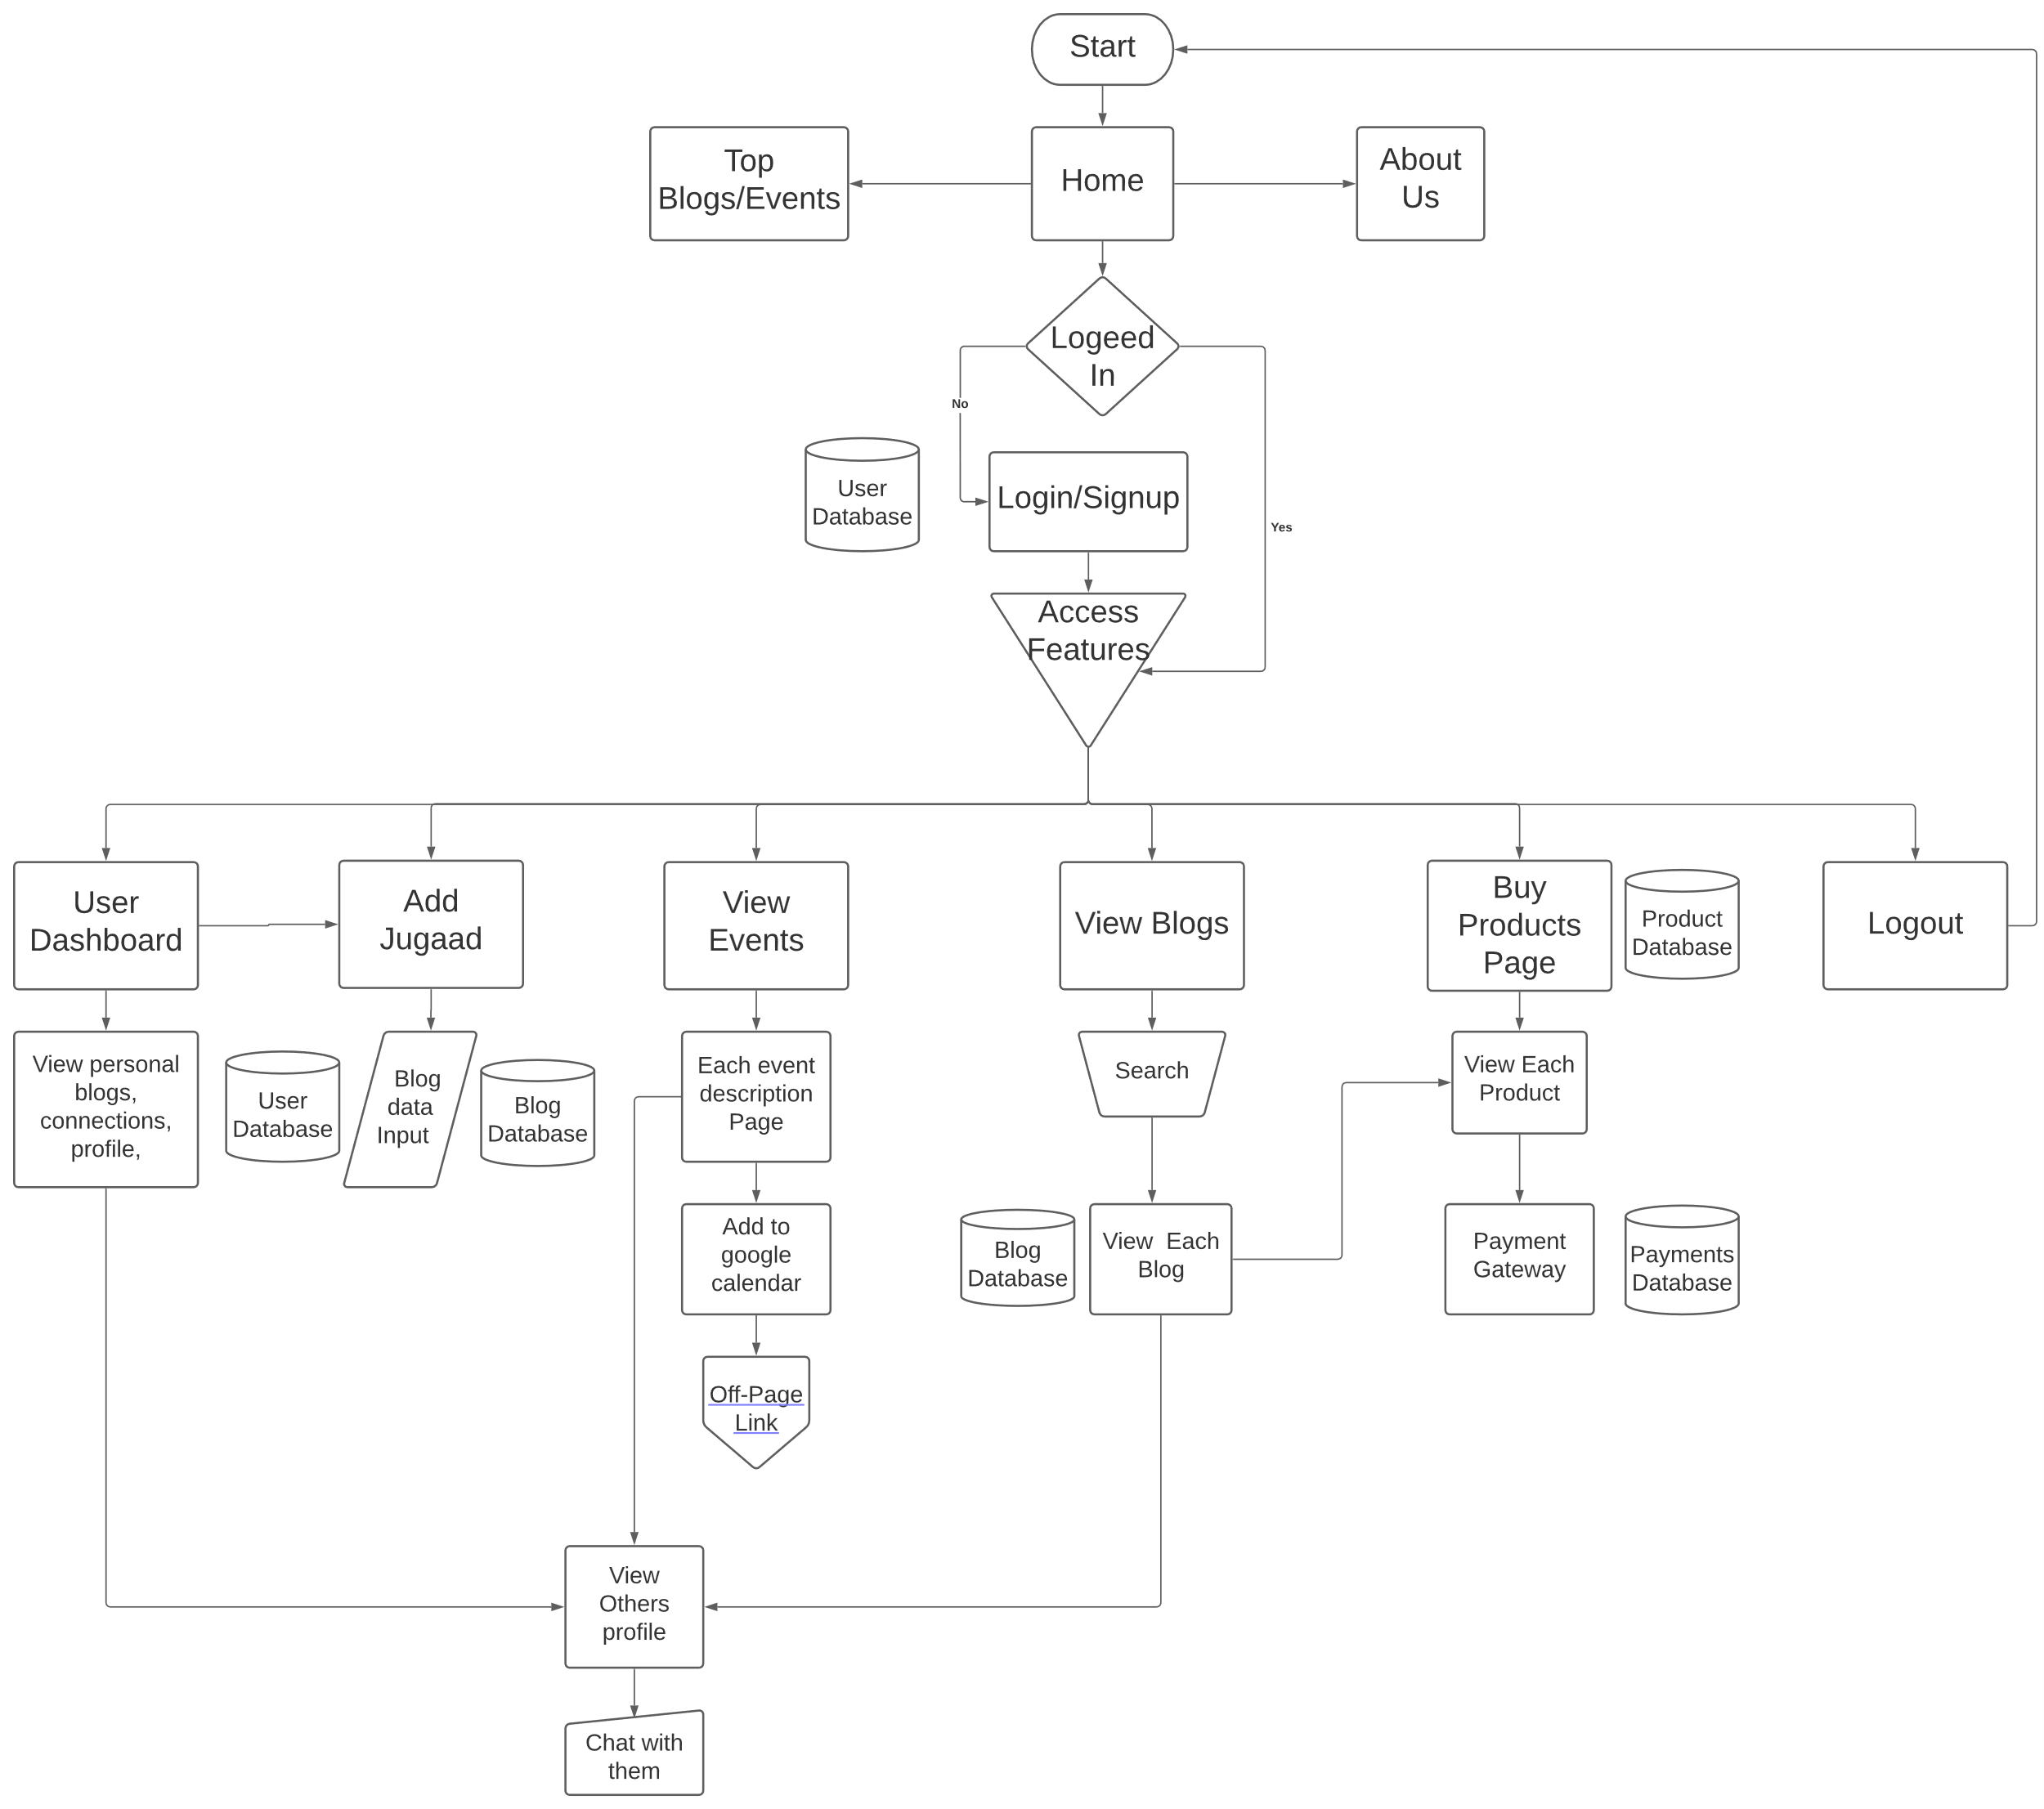

ER Diagram

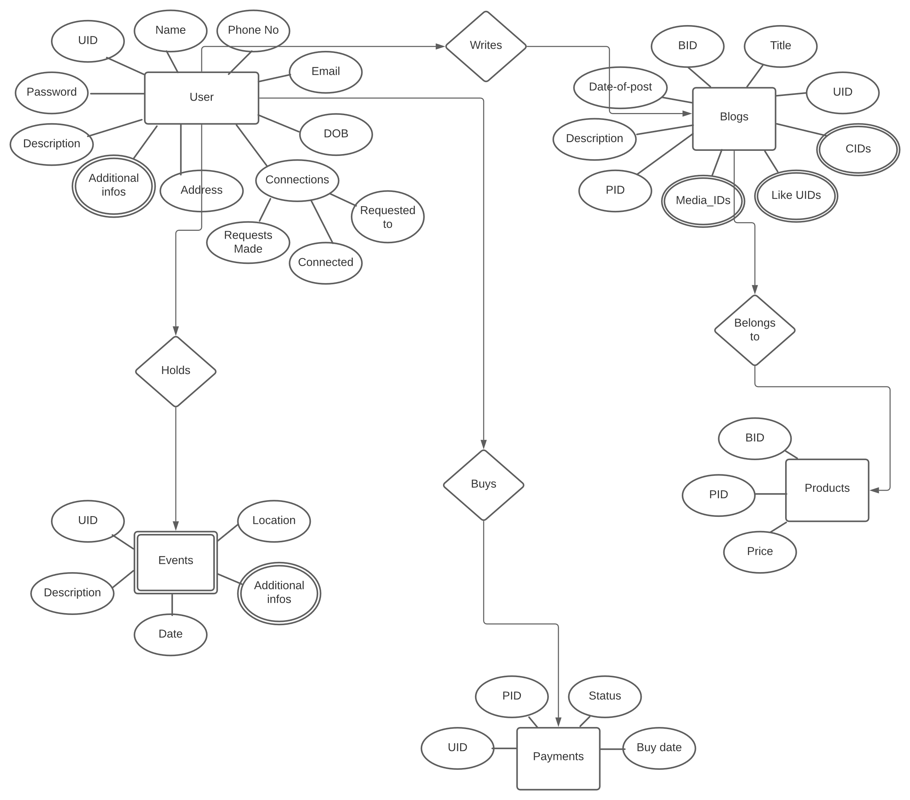

**Abstract**

The Hindi term "jugaad" refers to a temporary or improvised solution that makes use of limited resources. The art of finding chances in challenging circumstances so that the most may be made of limited resources is known as jugaad. The term "Jugaad" refers to a practical, adaptable, and open-minded method of problem solving and innovation in the corporate world. The major focus of our initiative is on sustainable development, which is an approach that is both process- and product-oriented.

This project proposes a web application which provides certain life hacks which will be in the form of a blogging and e-commerce website. Through this, visitors will learn how to manage their day-to-day waste products in an environmental-friendly and efficient manner. This will benefit the sustainability of resources. Via natural language processing, we will be optimizing product recommendation system to deliver smarter search results.

**Claims**

* To provide users with a common platform where they may learn how to create recyclable products from their everyday trash, Jugaad website is developed.
* They will gain independence since they will have a source of income from selling their products at fair prices on our e-commerce platform.
* The writers will be given credit for the Jugaad they created through their blogs**.**

**End users**

* The final consumers are those who are trying to find a purpose for the waste products they generate daily basis but are running out of inventive ideas.
* Those people who can do DIY upcycling hacks.
* All generations of consumers, from Baby Boomers to Gen Z, are eager to protect the environment, which creates a demand for jugaad.

**Advantage**

* Visitors to our website can view Jugaad solutions and learn how they can manage their day-to-day waste products in an environmentally friendly and efficient manner.
* This will benefit the sustainability of resources.
* Will establish a sense of innovation and creativity among its users which is a very need of the hour.

**Summary**

The innovation relates to providing economical, environmentally friendly items, freely exchanging ideas, and giving talented craftspeople from poor backgrounds respectable jobs. to aid India in managing its trash. Bringing back the Made in India concept using a sustainable strategy.